UHF RFID Integrated Reader
Software operation manual
- Content

1 Content 2
2 Software operation 4
2.1 Set up testing system 4
2.2 Edit the reader ip information text 4
2.3 Start up test software 4
2.3.1 Seril port connection 5
2.3.2 Network connecttion 6
2.4 Set reader parameter 7
3 The readering and writing test for ISO18000-6B tag 17
3.1 Program for reading and writing 17
3.2 Identify all the tag ID 17
3.3 Read data 18
3.4 Write HEX 19
3.5 Write protection 20
4 The reading and writing test for EPC Class1G2 tag 22
4.1 The program for reading and writing 22
4.2 Detect tag exist 23
4.3 Get the EPC number without condition 24
4.4 Get EPC Number according to the EPC data 25
4.5 Get EPC Number according to the TID data 26
4.6 Get theEPC Number according to The user data 27
4.7 Get EPC bank data of the specified tag 29
4.8 Read the TID bank data of specified tag 30
4.9 Get the USER bank data from specified tag 31
4.10 Get PASSWORD bank data from the specified tag 31
4.11 Write data to EPC bank of tag 32
4.12 Writer data into USER bank of specified tag 34
4.13 Modify the PASSWORD of tag 35
4.14 The write protection function for EPC BANK-TID BANK-USER bank of G2 tag 36
4.15 The write protection function for PASSWORD bank of G2 tag ……………………………………………………………………………………………………………..36
4.16 Write protection for EPC bank 37
4.17 Write protection for USER bank 38
4.18 The data block for USER bank 39
4.19 The read-write protect for PASSWORD bank 41
4.20 Kill tag 42
4.21 Alarm 43
4.22 Set reading protection 45
4.23 Release reading protection 46
5 The reading and writing test for ISO18000-6D tag 48
5.1 The reading writing program 48
5.2 Identify tag 48
5.3 Read and write data 49
5.4 Write character 50
5.5 Set page protection 51
5.6 Detect the page protection 52

- Software Operation
  - Set up testing system
Connect the equipment as illustrated below, structure a simple reader testing system in the studio:
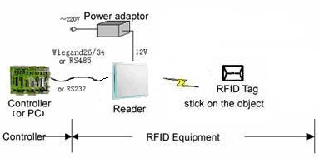
- Connect the reader module to PC through the RS232 port.
- Run the Demo software of the reader on PC, set reader index and test reading, writing for the reader according to the notes below.
  - Edit the reader IP information text
Double-click『IPAddress.ini』, open the file, see below, input all IP information which need to connect to this file, then store and close the file.
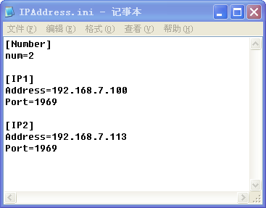

  - Start up test software
The CD-ROM for contains『application software』Reader1000. exe, this program needs to be in the running in under the environment of Microsoft Windows 95 or higher version of the operating system IBM pc-compatible computers. Run Reader1000. exe can start this software.
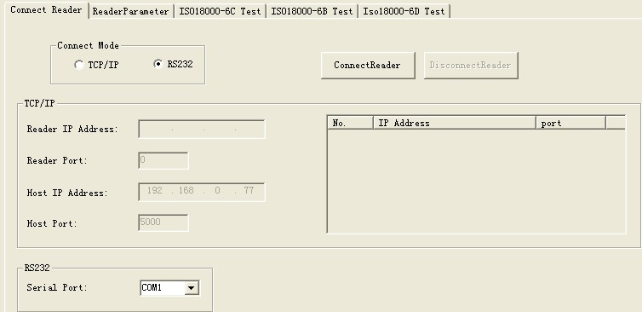
    - Seril port connection
PC can implement data exchange with reader through a serial port (RS232). Users get a new reader; usually have to do initialized Settings through a serial port, such as IP address, so that we can use network communication.
- Select the output port, see below.
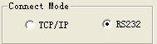
- Select the serial port for reader and PC.
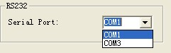
- Click『ConnectReader』button, if connected success, Popup the following clew box.
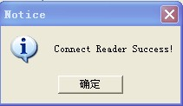
- If no reader connected to PC through this serial port, or the selected serial port is wrong, the connection will fail, Popup the following clew box.
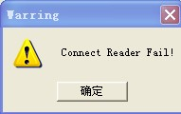
    - Network connection
PC can implement data exchange with reader through（TCP/IP）.
- Select the network connection mode, see below.
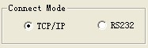
- Select the reader IP address from the below clew box.
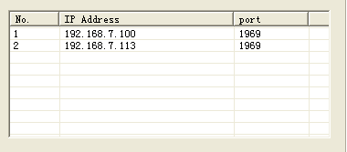

- Or diredtly input the IPAddress of Reader and Port of Reader to the below clew box.
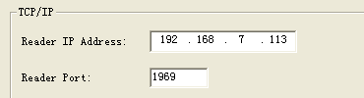
- Click『ConnectReader』button, if connect success, popup the below clew box.
- If no reader connected to PC through RJ45 port, or the the inputted IP information is wrong, the connection will fail, Popup the following clew box.
  - Set reader parameter
Below is the operation page for setting parameter for -『set parameter』:
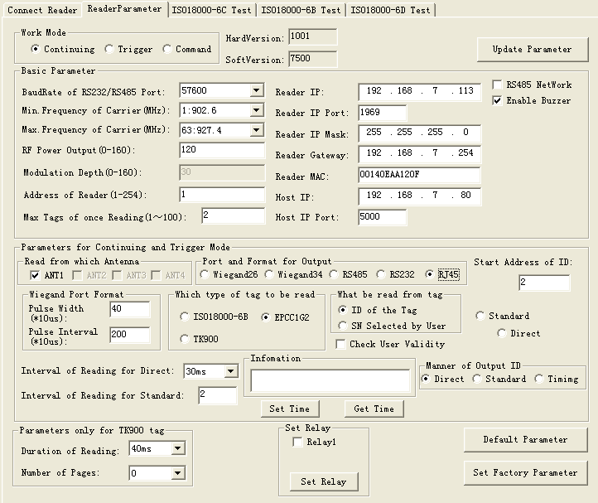
- Select Operation Mode
There three operating mode for as below:
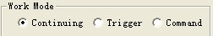
- Command: work in this mode, reader only implement after receive legal control command through RS232 or RS485, and return thecommand results through the same port.
Remarks: Every time run the Demo program and connect the reader success, it will be transferred to command mode automaticly.
- Timing: output read results reader setout signal automatic every once in a while, read label numbers, if read successful (or legal tags - need validation), then output read results from setting port (Wiegand and RS485 or RS232). If read fail or read illegal tag (need validation), then there is no output.
- Trigger: work in this mode, reader detects signal change on FIN1 pins automaticly, when detect low electricity at ordinary times; reader starts to send a signal, read label numbers. When FIN1 pins back to high level, stop reading card. The readed card number output from the setted data port. If read invalid card, then output 0xffffffff.
- Basic Parameters
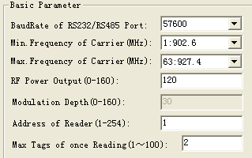
No matter in which operation mode, the below four parameters have to set.
- Baud Rate of RS232/485 Port: set communication rateof RS232 and RS485 port, can select from 9600, 19200, 38400, 57600, 115200bps.
- Max Tags of once Reading: Set the most number of labelto read at one time. This parameter should be determined according to the specific requirements. For how labels in antenna radiation within the scope of application at the same time, setting should be larger. But set lower values can improve the speed of reading card.
- RF Power Output: set the output power for the reader. The param has been set to the optimal value; mean has the optimal reading distance and effect. If no special request, please don’t modify this param.
- Min. Frequency of Carrie): set the min operaton frequency for the reader.
- Max. Frequency of Carrier: set the max operaton frequency for the reader.
- For different countries or regions, because local radio rules requirement, have corresponding choice scope of listed the working frequency. Users can choose sensitive frequencies according to local conditions. if just choose a Frequency point, set the Min. Been Carrier and Max to the same; If need to use Frequency hopping, can choose the Min. W.t. fmin Carrier for been, Max. The Carrier for fmax been w.t., as long as fmax > fmin. As below:
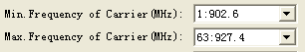
- Setting buzzer: close buzzer, the buzzer don’t sound when identified tag, only show tag information on the interface, open the buzzer, the buzzer sound when identified tag, and show tag information on the interface.
- Set network parameter
The network param has t o be set before connect the reader and PC through TCP/IP.
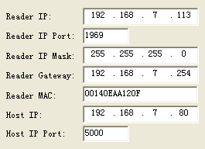
- Set RS485 network
Can make networking through RS485. It has to set an address for each reader before make networking, and enable the reader can connect with PC through TCP/IP. Address range: 0 to 255.
Remarks: 0 and 255 are broadcast address，all reader will return application information after receive command with broadcast address.
- Set networking function: make it can set networking, the reader only execute the command which has address; make it has no networking function, the reader only execute the command which has no address.
- RS485 network address(1～254): The reader address will set.
- Relay control.
Select relay1 or relay2 or select both, click『relay control』means close relay,popup the clew box for set successful. Don’t select relay1 or relay2, means the relay opened.
Parameters for Timing and Trigger Mode
The param in the below picture are effected for triger and timing operating mode:
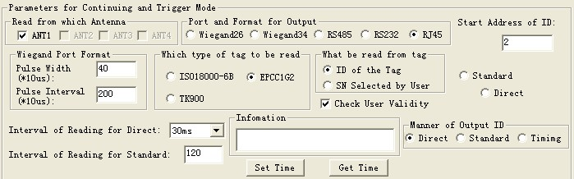
- Read from which Antenna: only use the middle one. If choose the timing or trigger mode, it has to select in advance according actual situation.
- What will be read from tag: General select the ID No. of the tag as labels No. But for the entrance application, sometimes users need to define their own tags Numbers, and requires to read the writing Numbers as labels Numbers. So should select due to actual situation:
 | EPC C1G2 | ISO18000-6B | TK900
ID of the Tag | EPC | ID | ID
SN Written by User | TID | The data from 220～223 of user | no
- Port and Format for Output: the tag No. readed automaticly can output from RS232、RS485、wiegand. If output from Wiegand, it also has to set output from wiegand26 or Wiegand34 format.
The relationship among utput port、output tag ID bits and and tag species.
 | EPC C1G2 | ISO18000-6B | TK900
RS232/485/RJ45 | All EPC bits | The operating param 『initial address of output card』determin output 32bits of 64 bits ID | Total 64bits ID
wiegand 26 | The operating param 『initial address of output card』determin output 32bits of 64 bits ID | The operating param 『initial address of output card』determin output 24bits of 64 bits ID | The operating param 『initial address of output card』determin output 24bits of 64 bits ID
wiegand34 | The operating param 『initial address of output card』determin output 32bits of 64 bits ID | The operating param 『initial address of output card』determin output 32bits of 64 bits ID | The operating param 『initial address of output card』determin output 32bits of 64 bits ID
- Wiegand Port Format: there are three kind of Pulse Width and Pulse Interval can be selected for users(as below),usually default to Pulse Width be 28，Pulse Interva be 5.
Pulse Width | Pulse Interval | Pulse Width of Wiegand port | Pulse Interval of Wiegand port
40 | 200 | 400us | 2ms
10 | 160 | 100us | 1.6ms
5 | 100 | 50us | 1ms
- Start Address of ID (0-4): it is for tag ID, the ID of tag has 8Bytes, address0-7.
The relationhip among initial address of output tag No、tag species and the data of tag No.（the output port:Weigand26）
The initial address range of output tag No. | EPC C1G2  (112233445566778899001122) | ISO18000-6B  (E0044BDF23010000) | TK900  (0580C6B1574226A2)
0 | 223344 | 044BDF | 80C6B1
1 | 334455 | 4BDF23 | C6B157
2 | 445566 | DF2301 | B15742
3 | 556677 | 230100 | 574226
4 | 667788 | 010000 | 4226A2
5 | 778899 | Not be usable | Not be usable
6 | 889900 | Not be usable | Not be usable
7 | 990011 | Not be usable | Not be usable
8 | 001122 | Not be usable | Not be usable
The relationhip among initial address of output tag No、tag species and the data of tag No.（output port: Weigand34）
The initial address range of output tag No. | EPC C1G2  (112233445566778899001122) | ISO18000-6B  (E0044BDF23010000) | TK900  (0580C6B1574226A2)
0 | 11223344 | E0044BDF | 0580C6B1
1 | 22334455 | 044BDF23 | 80C6B157
2 | 33445566 | 4BDF2301 | C6B15742
3 | 44556677 | DF230100 | B1574226
4 | 55667788 | 23010000 | 574226A2
5 | 66778899 | Not be usable | Not be usable
6 | 77889900 | Not be usable | Not be usable
7 | 88990011 | Not be usable | Not be usable
8 | 99001122 | Not be usable | Not be usable
The relationship among initial address of output tag No、tag species and the data of tag No.（output port: RS232/485）
The initial address range of output tag No. | EPC C1G2  (112233445566778899001122) | ISO18000-6B  (E0044BDF23010000) | TK900  (0580C6B1574226A2)
0 | 112233445566778899001122 | E0044BDF | 0580C6B1574226A2
1 | 112233445566778899001122 | 044BDF23 | 0580C6B1574226A2
2 | 112233445566778899001122 | 4BDF2301 | 0580C6B1574226A2
3 | 112233445566778899001122 | DF230100 | 0580C6B1574226A2
4 | 112233445566778899001122 | 23010000 | 0580C6B1574226A2
5 | 112233445566778899001122 | Not be usable | Not be usable
6 | 112233445566778899001122 | Not be usable | Not be usable
7 | 112233445566778899001122 | Not be usable | Not be usable
8 | 112233445566778899001122 | Not be usable | Not be usable
- Parameter only for continuing Mode
The below parameter is only suitable for continuing operation mode:
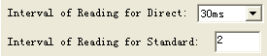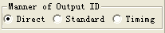
- Interval of Reading: means how long pause after each time reading, can select from 30ms，50ms，100ms. Usually identify the slow motion object, the interval time can be long, conversely, it should be short. This param is effected not Wiegand output port. For Wiegand output port, output interval fixed to be 1 second.
- Manner of output ID: for continuing mode, directly output result or not each time read tag.『directly』represents output immediately once get ID『standard』represents if get the same ID within a long time, output one time defaultly according to the value of 『output interval』, if get the different ID, output it immediately;『timing』represents if get the same ID within long time, and the ID stay in this area, then output one time; if get the same ID within long time, but the leaving time for the tag was long than the value of 『output interval』, once the tag enter again, output its ID immediately.
- Use the legality parameter（is optimal）
Select reader wouldn’t check if the tag ID is legality or not, output to PC directly.
Reader will check if the tag ID is legality or not; if it legality, output to PC, if unauthorized, the reader wouldn’t output the tag ID to PC.
- Set reading time
The reader has clock, click『set time』button can set time for reader throughPC. Click 『get time』button, PC can get the time information on the reader.
- Set TK900 Tag specified parameter.
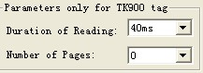
The identify progress for TK900 tag, inquires the signal (sending constant RF signal), during the inquiry signal period, tag response ID randomly. Inquires the signal lasting time too short, certain tags may not response; Continuous time is too long, reading speed ill be slow.
Perminently reading time: the perminently time presents inquiry signal have 5ms、10ms、20ms、30ms、40ms、50ms、160ms, it is optimal.
The number of reading card: represents the number of reader sending information after receive a command from PC.
Default Parameter: Reader has certain parameters Settings in factory, if the user has modified some param in use process, and then want to recover to the factory setted parameters, then click the『default parameters』button, you can resume originally set of parameters.
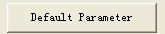
- Update Parameter
Once the parameter selected, click『update parameters』button to write the param to reader’s memory. After success, restart the reader and PC program, the reader will reset param.
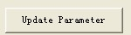
- The readering and writing test for ISO18000-6B tag
  - Program for reading and writing
If have to test functionality and performance of the reader, it can be made according to the following way operation. First introduce the operatin way for ISO18000-6B standard tag as below:
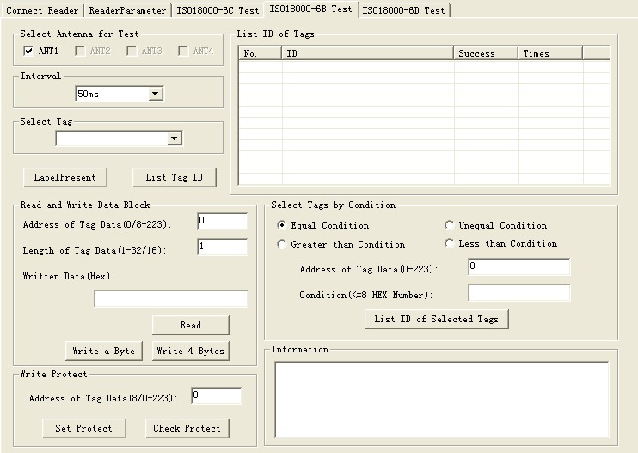
  - Identify all the tag ID
Operation steps as below:
Set antenna: can connect an antenna, may use the several antenans, may use just one among them. User can choose it according to actual condition.
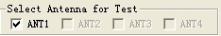
Press the 『identification tag』button, and place tags in antenna radiation field, reader began repeated read ID of tag automaticly, until pop-up 『identification tag』button.The card number showed in the『show identified label ID』frame as below:
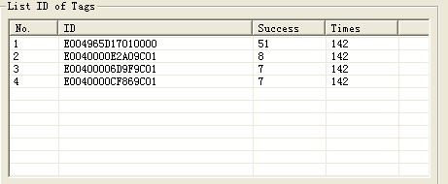
Remove the tag during the antenna radia frequency area can test the reading distance and range.
  - Read data
The start address of reading is 0-223.
The length range of reading block is 1-32.
The operating step for testing the reader’s『read』function is as below:
  - Select a tag which will be read from『select a tag』frame (this frame show the result of『list all tag ID』).
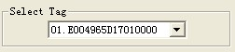
  - Select the initial address and block length of reading operaton. 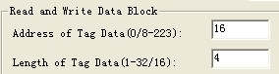
  - Press『get data』button, the program will start repeatly read automaticly until pop-up this button.
  - The reading result showed at the『informaiton frame』.
Each line displayed the result of one reading operation, display with Hex firstly.
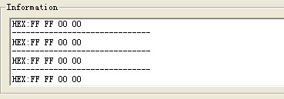
  - Write HEX
The initial address range of writing operation is 8-223.
The block length of writing operation is 1-16.
The operating step of test reader’s『write』function:
  - Select a tag which will write data from『written data』.
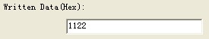
  - Input the initial address of writing operation.
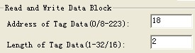
  - Press『write data』button, the program will start repeat write data automaticly until pop-up the button.
  - Write success or not showed in the『informaiton frame』, see below.
  - 『write success！』represents this operation success.
『write fail!』represents this operation failed, the reason may be distance is too long 、this bank write protection or has been damaged.

Remarks: if the written data more than 4tytes,『writen fail!』may due to patial bytes written failed.
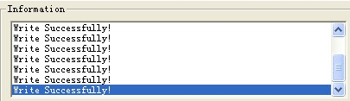
  - The condition for indentifing the tag: users can select the suitalble tag ,then click 『identify tag with condition』button, the tags meet the conditions will be read and show in "show was identification tag ID" column, not content will not be read.
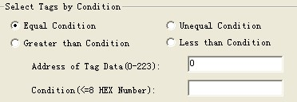
  - Write protection
The operation step is as below:
  - Select a tag which will plan to protection from『select a tag』.
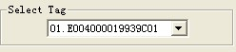
  - Add the address of the tag in 『write protection』frame. The address range is 8-223.
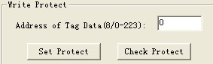
  - Press『set protection』button, popup dialog, see as below:
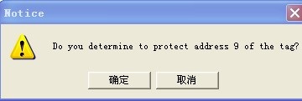
  - Press 『yes』, program will continue protect this tag. If failed, will popup the below dialogue frame:
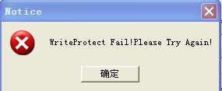
  - Press 『yes』,try again, protection success, will pop up the below dialog frame:
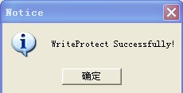
  - Detect the specified bank of the tag been protected or not (detect address range is 0-223). Press『detec the protection situation』button, pop up the below frame show that this specifed bank has been protected.
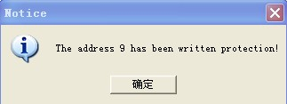
- The reading and writing test for EPC Class1G2 tag
  - The program for reading and writing
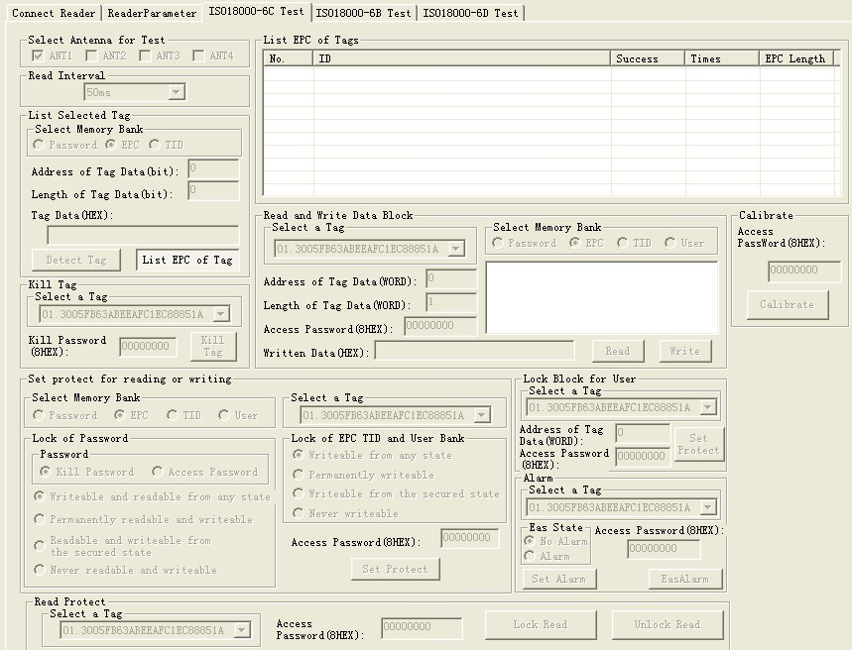
- The storage unit of EPCC1G2 tag.
Devided into four banks:
- EPC: area for storage EPC code, it can store 96Bits EPC code at most. Read write.
- TID: area for storage the ID number setted by the factory, have two kind ID number 32 and 64 bits at present. Only can be read
- User: it is differenct in different. The G2 tag from Inpinj has no User area. Philips has 96Bits user area, read write.
- Password: 32Bits access password and 32Bits kill password. Read write.
The four bank all can be write proction. Write protection means this bankwill never be writable or can’t write at the unsate situation; read protection means the password bank can’t be read.
- The reading and writing step for EPCC1G2 tag
It is devided into three steps:
  - Selection: select a bank at first, then select a group a tags according to specified data in this bank.
  - Inquiry tag one by one: identify all the tags one by one based on the selection.
  - Access: access an identified tag. Such as read write the four bank, set read write protection and modify password.
- Set antenna.
Select an antenna for test: can select several antenna ports ora single port.
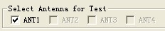
- Set interval
The reading interval can select from:10、20、30、50、100、200 and 500ms,default is 50ms.
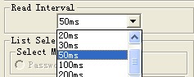
  - Detect tag exist
The main function is detect read protect tag. Because in identification tag, read protection tags do not return EPC, only return to full zero data.
Press『detect tag』button, the PC send detection command to reader, the reader return the detection result to PC, this process continues 3 seconds later, PC will give detection results.
If detected read protected tag, show『have read protected tag within the radio frequency area』.
If detected read tag without read protected, show『have tag within the radio frequency area』.
If detected no tag, show『no tag within the radio frequency area』.
  - Get the EPC No. without condition
Operating steps are as below:
Firstly, select any bank except the password bank, such as EPC bank, see below:
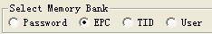
Secondly, set the initial address of data bank to be zero, 0 represents identify all the tag within radio frequency need no condition. See below:
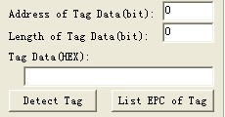
Thirdly, press『identify tag』button, reader get EPC No. According to last step. The identified EPC No. showed in the top right corner『show identified tag ID』dialogue frame.
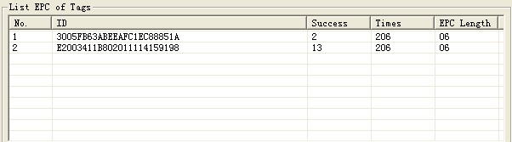
Figure4.3
  - Get EPC No. according to the EPC data
According to the specific data segment in EPC bank, choose tags meet the condition, read their EPC number.
Operating steps are as below:
Firstly, select any bank except the password bank, such as EPC bank, see below:
Secondly, set the initial address of data bank, unit with Bit, the start address only should be whole number. Such as the 12.
Thirdly, set the length of the data, unit by Bit, such as 3.
Fourthly, select data choose HEX for the unit, such as 4, see below. Here the so-called conditions is aimed at a regional data in some tags consecutive patients (bit), who meet the conditions of the tag will be read. The length of the conditional values is not 4Bits integer times, low fill 0.
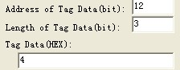
Fifthly, press "identification tag" button, reader began to read the label EPC number according to the first four steps setted conditions. Illustrate: see chart 5.1, radiation field have eight tag, if have to meet the conditions: data area initial address is 12, the data length is 3 (namely needs to compare three), selected data is C, the only one card whose ID is 5555555555555555555555 meet, and list to show, see figure 4.3 (because the start bit of card id 12, need to compare the condition of the length is 3, if meet conditional values for hexadecimal 4 or 5 (010 low fill a zero convert 0100 or 0101). Be identified label’s EPC number displayed in the upper-right corner "show identified label ID" dialog box as below:
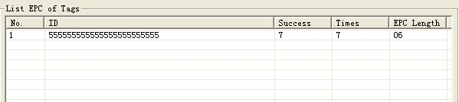
  - Get EPC No. according to the TID data
According to the specific data segment in TID bank, choose tags meet the condition, read their EPC number.
Operation steps are as below:
Firstly, select any bank except the password bank, such asTID bank, see below:
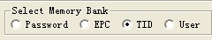
Secondly, set the initial address of data bank, unit with Bit, the start address only should be whole number. For example: 43.
Thirdly, set the length of the data, unit by Bit, such as 4.
Fourthly, select data choose HEX for the unit, such as 4, see below. Here the so-called conditions is aimed at a regional data in some tags consecutive patients (bit), who meet the conditions of the tag will be read. The length of the conditional values is not 4Bits integer times, low fill 0.
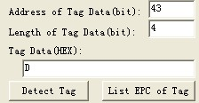
Fifthly, press『identification tag』button, reader began to read the label EPC number according to the first four steps setted conditions. Illustrate: see chart 5.1, radiation field have eight tags, If have to meet the conditions: data area initial address is 43, the data length is 4 (namely needs to compare 4), selected data of D, only card whose ID is 3005FB63AC1F3841EC885555 TID area for E2006004009AE045 meet the condition, and then showed as below:
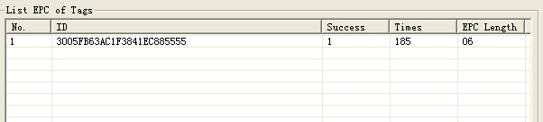
  - Get theEPC No. according to user data
According to the specific data segment in TID bank, choose tags meet the condition, read their EPC number.
Operation steps are as below:
Firstly, select any bank except the user bank, such asTID bank, see below:
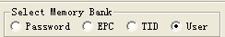Secondly, set the initial address of data bank, unit with Bit, the start address only should be whole number, such as 7.
Thirdly, set the length of the data, unit by Bit, such as 3.
Fourthly, select data choose HEX for the unit, such as2, see below. Here the so-called conditions is aimed at a regional data in some tags consecutive patients (bit), who meet the conditions of the tag will be read. The length of the conditional values is not 4Bits integer times, low fill 0.
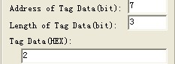
Fifthly, press『identification tag』button, reader began to read the label EPC number according to the first four steps setted conditions. Illustrate: radiation field have several tags, if have to meet the conditions: start address is 7, the data length is 3 (namely needs to compare three), selected data to be 2, and then only for the user ID 053000000000000000000000 data for 32454DAE card meet the condition and listed to show, see figure 5.6 (because the start bit is 7, need to compare the condition of the length is 3, if meet conditional values for hexadecimal 2 (001 low fill a zero convert 0010) . Identified label EPC number displayed in the upper-right corner "show is identified label ID" dialog box as below:
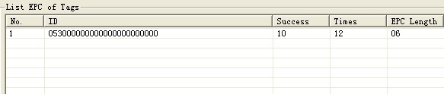
  - Get EPC bank data of the specified tag
EPC bank of EPCC1G2 tag have three parts, order is as follows: CRC-16 is PC value and the redundancy circular check cod of EPC No, CRC are 16Bits, is the FC4BH in the picture.
- PC comperent from the length of EPC No. and application code.The length of PC value is 16Bits, is the 3000H in picture.
- EPC is EPC No. Picture 4.6: 0530H (the first character of EPC No.).
Can read any EPC block data, operating steps are as below:
The first step, select EPC storage area, as below:
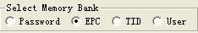
The second step, select tag, for example『0530000000000000000000』, as below:
The third step, select the start address of the data, unit by character, such as 0, as below:
The fouth step , set the length of the tag, unit by character, such as 3, as below:
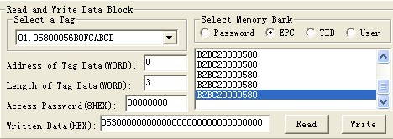
The fifth step, press『read data』button, reader began to read the label EPC number according to the first four steps setted conditions. The data displayed in the upper-right corner.
  - Read the TID bank data of specified tag
Can read any TID block data, operating steps are as below:
The first step, select TID storage area, as below:
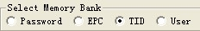
The second step, select tag, for example『3005FB63AC1F3841EC880467』, as below:
The third step, select the start address of the data, unit by character, such as 0, as below:
The fouth step , set the length of the tag, unit by character, such as 3, as below:
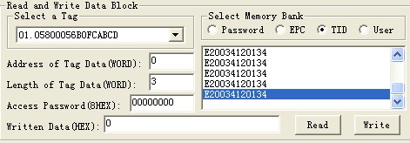
The fifth step, press『read data』button, reader began to read the labelTID number according to the first four steps setted conditions. The data displayed in the upper-right corner.
  - Get the USER bank data from specified tag
Can read any USER block data, operating steps are as below:
The first step, select USER storage area, as below:
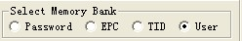
The second step, select tag, for example『3005FB63AC1F3841EC880467』, as below:
The third step, select the start address of the data, unit by character, such as 0, as below:
The fouth step , set the length of the tag, unit by character, such as 3, as below:
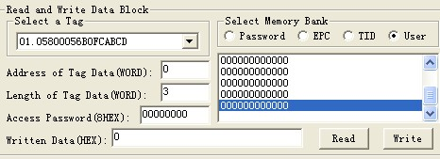
The fifth step, press『read data』button, reader began to read the label USER number according to the first four steps setted conditions. The data displayed in the upper-right corner.
  - Get PASSWORD bank data from the specified tag
If the password does’t be read protection, it can read any password block data; the password bank has two parts as below:
(1) Kill password: 32Bits
(2) Access password: 32Bits
Operating steps are as below:
The first step, select password storage area, as below:
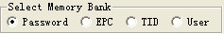
The second step, select tag, such as 『777777777777777777777777』, see below:
The third step, select the start address of the data, unit by character, such as 0, as below:
The fouth step set the length of the tag, such as 4, as below:
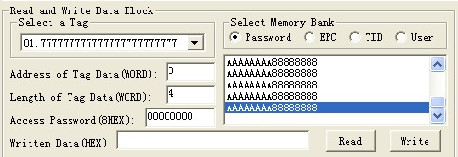
The fifth step, press『read data』button, reader began to read the label USER number according to the first four steps setted conditions. The data displayed in the upper-right corner. AAAAAAAA is kill password, 88888888 is access password.
  - Write data to EPC bank of tag
Can write16、32、48、64、80 or 96Bits EPC No to the EPC bank at present. CRC-16 and PC value automatic generation according to written EPC. The operation steps are below:
The first step, select EPC storage area, as below:
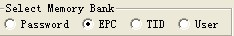
The second step, set the EPC No. length, such as 6, means 96Bits, see as below:
The third step, if the EPC bank has been set password lock, should fill『Access password』, such as 88888888, see as below:
The fourth step, fill EPC No. to 『writen data (Hex.)』, united by HEX,such a『45679464ABCDABCD35467684』.
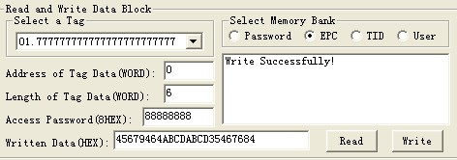
The fifth step, press『write data』button, reader began to write the label EPC data according to the first four steps setted conditions. The written data displayed in the upper-right corner.
The sixth step, get EPC No., check if the written right or not.
Remark:
- Only one tag can be there within the radio frequency, otherwise, several tags may all writed the same EPC No. As wrete EPC No. don’t choose a specified tag, so don’t have to choose『select a tag』.
- All EPC No. are write from address 0, reader pay no attention to『the start address for data area』.
(3) When the written data more than 2bytes, show wrong information, may only partial data has been written wrong.
  - Writer data into User bank of specified tag
The operation steps as below:
The first step, select USER storage area, as below:
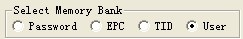
The second step, select a tag, such as『45679464ABCDABCD35467684』, see as below:
The third step, select the initial address of user bank, such as 0, see as below:
The fourth step, set the length of data, such as 4, see as below:
The fifty step, if the user bank has been set password, then has to fill the『Access password』, such as 88888888 see as below:
The sixth step, fill data to『written data(Hex.)』, such as『1234567891234567』.
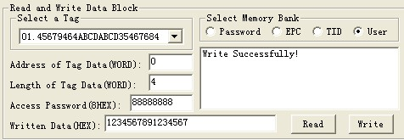
The seventh step, press『written data』button, reader began to write the label USER data according to the first four steps setted conditions. The written data displayed in the upper-right corner.
The eighth step, get USER No., check if the written right or not.
Remark:When the written data more than 2bytes, show wrong information, may only partial data has been written wrong.
  - Modify the PASSWORD of tag
The operation steps are as below:
The first step, select password storage area, as below:
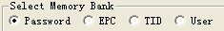
The second step, select a tag, such as『45679464ABCDABCD35467684』, see as below:
The third step, select the initial address of user bank, such as 0, see as below:
The fourth step, set the length of data, such as 2, see as below:
The fifty step, fill the『Access password』, such as 88888888, see as below:
The sixth step, fill new password to『written data(Hex.)』, such as『AAAAAAAA』.
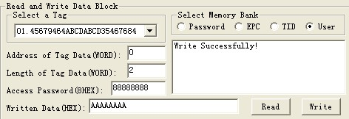
The seven step, press『write data』button, reader begin to write password according to the condition set be the above sixth step, such as write kill the tag. The written data displayed in the upper-right corner.
The eighth step, get new password, check if the written right or not.
Remark: When the written data more than 2bytes, show wrong information, may only partial data has been written wrong.
  - The write protection function for EPC BANK-TID BANK-USER bank of G2 tag
The TID bank of G2 tag has been locked forever by the manufacturer is readable only.
The EPC bank and USER bank of G2 tag has no protection for reading, the write protection as below:
Writable from any state- can write without password, and can set to permanently writable, Writable from the secured state or Never writable in the future.
Permanently writable- can write without password, and can’t set to be Writable from the secured state and Never writable;
Writable from the secured state- only can write with the password, and can set to permanently writable, Writable from the secured state or Never writable in the future.
Never writable-can’t write even with password.
  - The write protection function for PASSWORD bank of G2 tag
The password of G2 tag can be read and write proteted, the password situation wouldn’t effect use the password. Protection function:
Readable and Writable from any state- can read and write without password, and can set to permanently Readable and writable, Readable and Writable from the secured state or Never reader or writable in the future.
Permanently readable and writable- can read and write without password, and can’t set to be readable or Writable from the secured state and Never readable or writable;
Readable and Writable from the secured state- only can read orwrite with the password, and can set to permanently readable and writable, readable and Writable from the secured state or Never readable or writable in the future.
Never readable or writable-can’t read or write even with password.
Remarks: set read write protect for tag, should know the access password of tag in advance.
  - Write protection for EPC bank
The first step, select the EPC bank,as below:
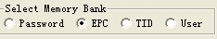
The second step, select a tag, such as『45679464ABCDABCD35467684』,as below:
The third step, select the Writable from the secured state (or Writable from any state, or permanently writable or never writable), as below:
The fourth step, fil the l『access password』,the access password for tag『45679464ABCDABCD35467684』is 88888888, see as below:
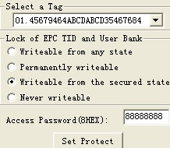

The fifth step, press『set protecting』button, popup the below dialogue box:
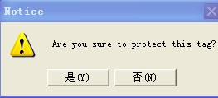
The sixth step, press『no』, then the above operation invalid, press『yes』,according to the before four step setted condition, if success, popup the below frame, represents the EPC bank has set to be password lock.
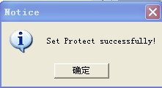
The seventh step, write data to EPC bank, check if the set protection suceess or not.
  - Write protection for USER bank
The first step, select the USER bank, as below:
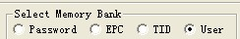
The second step, select a tag, such as『45679464ABCDABCD35467684』, see as below:
The third step, select the Writable from the secured state (or Writable from any state, or permanently writable or never writable), as below:
The fourth step, fill the l『access password』,the access password for tag『45679464ABCDABCD35467684』is 88888888, see as below:
The fifth step, press『set protecting』button, popup the below dialogue box:
The sixth step, press『no』, then the above operation invalid, press『yes』,according to the before four step setted condition, if success, popup the below frame, represents the EPC bank has set to be password lock.
The seventh step, write data to USER bank, check if the set protection suceess or not.
  - The data block for USER bank
Only the SL3-ICS-10 UCODE EPC G2 tags from Philip provide this kind of lock. Each block has 32bits (4bytes or 2 words). Once the block has been locked, it can’t be modified forever.
The first step, select a tag, such as『45679464ABCDABCD35467684』, see as below:
The second step set the data address, such as 6 or 7, will protect 6 and 7two words as below. The SL3-ICS-10 tag has 14 Words at present,the address is 0～13.
The initial addres(character) | The data been protected (character)
0 or 1 | 0 and 1
2 or 3 | 2 and 3
4 or 5 | 4 and 5
6 or 7 | 6 and 7
8 or 9 | 8 and 9
10 or 11 | 10 and 11
12 or 13 | 12 and 13
The third step,fill the access password, the access password of tag『45679464ABCDABCD35467684』is 88888888, see as below:
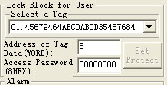
The fourth step, press『set lock』button, popup the below dialogu box:

press『yes』button, the reader will send block lock command to the tag, if success, PC will popup the below frame.
Set lock success or not, operate to check it.
If fialed, will popup error information accordingly.
  - The read-write protect for PASSWORD bank
The first step, select the user bank, see below:
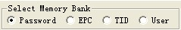
The second step, select the access password (or kill password), see below:
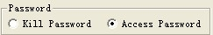
The third step, select a tag, such as『45679464ABCDABCD35467684』, see below:
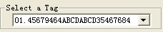
The fourth step, select the Readable and Writable from the secured state (or Readable and Writable from any state, or permanently readable and writable or never readable or writable), as below:
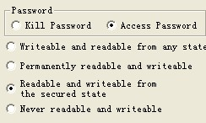
The fifth step, fill the『access password』, the access password for tag『45679464ABCDABCD35467684』is 88888888, see below:
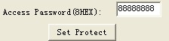
The sixth step, press『set protection』button, popup the below frame:
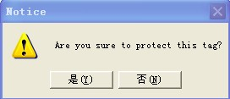
The seven step, press『no』, then the above operation invalid, press『yes』,according to the before four step setted condition, if success, popup the below frame, represents the USER bank has set to be password lock.
The eighth step, write data to USER bank, check if the set protection suceess or not.
  - Kill tag
Once the tag has been killed, it will never answer the reader.
Remarks: this function should be cautious to use.
The first step, select a tag『Select a Tag』, such as『222222222222222222222222』, see below:
The second step, fill the kill password to『Password』, HEX. , the kill passwordof tag『222222222222222222222222』is 00000000, see as below；
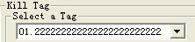
The third step, press『Delete Tag』button, popup the below frame:
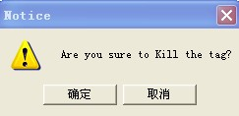
The foutth step, press『no』, then the above operation invalid, pres『yes』,according to the before three step setted condition, if success, popup the below frame, represents the tat has been killed.
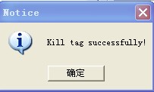
The fifth step, read the EPC No. to check if killed the tag successful or not.
  - Alarm
Only the SL3-ICS-10 UCODE EPC G2 tag of Philips has this function, this function is similar to the bar magnet used in library and supermarket. When the tag on the goods are under the alarm situation, once the reader find the tag will alarm.
Set alarm stature
The first step, select a tag, such as『45679464ABCDABCD35467684』,see as below:
The second step, fill the access password, Hex., the access password of tag『45679464ABCDABCD35467684』is 88888888, see as below:
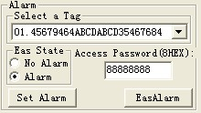
The third step, select 『alarm』
The fourth step, press『set alarm』button, reader send set alarm command , if success, popup the below frame:
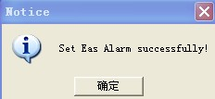
If failed, popup popbox, the failure reason may be the reader left the radiao frequency or the access password is wrong.
Check if set alarm successfully.
- Set no alarm
The first step, select a tag, such as『45679464ABCDABCD35467684』, see as below:
The second step, fill the access password, Hex., the access password of tag『45679464ABCDABCD35467684』is 88888888, see as below:
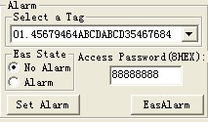
The third step, select 『no alarm』
The fourth step, press『set alarm』button, reader send set alarm command , if success, popup the below frame:
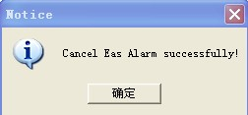
If failed, popup popbox, the failure reason may be the reader left the radiao frequency or the access password is wrong.
Check if set no alarm successfully.
- Check alarm
Press『EasAlarm』button, reader send check alarm command to tag. If found some tags are in the alarm situation, the buzzer will alarm, and there would be red light twinkle on the PC interface.
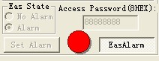
If haven’t foud any tag under the alarm situation, buzzer will not alarm and there would be no tips on the PC.
Once found the alarm, shut up the relay 4 seconds, if found alarm again,the relay will delay 4 seconds to shut up.
  - Set reading protection
Only the Philips SL3-ICS-10 UCODE EPC G2 tag has these two functions, the reading protected tag only return zero data to the identification command from the reader, but not EPC.
The first step, select a tag, such as『222222222222222222222222』, see as below:
The second step, fill the access password, Hex., the access password of tag『222222222222222222222222』is 11111111, see as below:
The third step, press『set reading protect』button, reader send out set reading protecting command, if success, will pop up the below frame:
If reader found no tag, will popup the below frame:
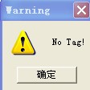
If the access password is wrong, then popup the below frame:
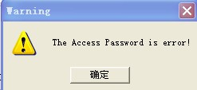
If the tag don’t have this function, will popup the below frame:
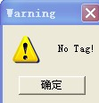
  - Release reading protection
Once the tag been reliefed protection, the information in tag can return EPC nomally. Remarks: For reliefing the reading protection, there should be only one tag in the radio frequency.
The first step, fill the access password, such as『AAAAAAAA』；
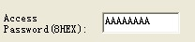
The second step, press『releif reading protecting』button, reader send relief command to the tag, if success, popup the below frame:
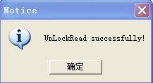
If reader found no tag, will popup the below frame:
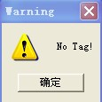
If the access password is wrong or the tag doesn’t have this function, then popup the below frame:
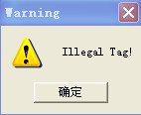
- The reading and writing test for ISO18000-6D tag
  - The reading writing program
To the TK900 tag, operate as below:
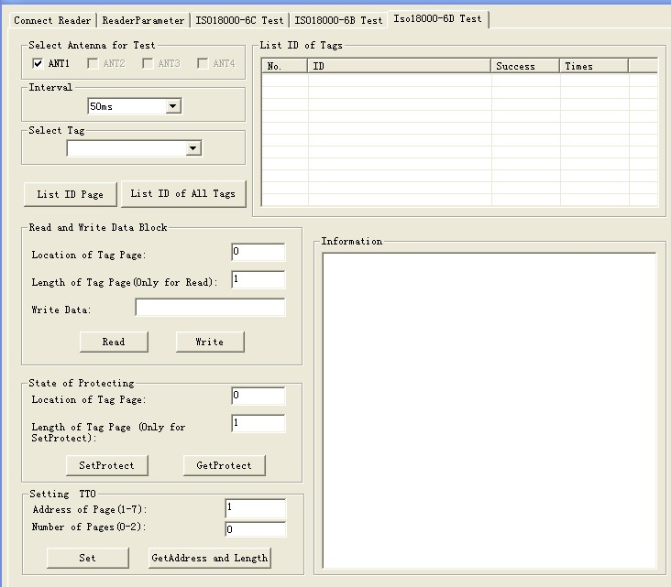
  - Identify tag
The operation step is as below:
Select antenna
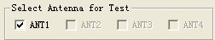
  - Lay a tag in the radio frequency area, press『identify tag』button, the reader begin to get the ID of tag reapedly and automatically, until popup this button. The No. showed in the『Showing the identified ID』frame, as below;
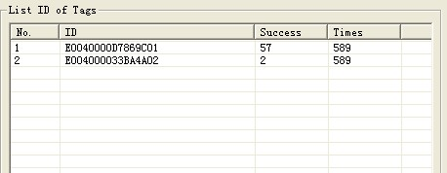
『Showing the identified ID』listed all the ID No. Has been identified. Remove the tag within the radio frequency area, can check the reading range.
  - Read and write data
ISO18000-6D don’t have the user bank, EM4422 and EM4442 have 15 pages user bank, 8bytes per page.
The range of data start address: 0-14.
The length range of data page: 1-15.
The operating step for test reader’s『read』function is as below:
  - Select a tag which is reading to be read from the『select a tag』frame(this frame showed that『list all tag’s ID』 )
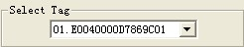
  - Set the start address for reading, such as 0. Set the page for reading, such as10. see as below:
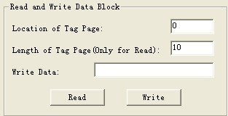
  - Press『read』button, the program will start reading repeatedly and automatically, until popup this button. The result will show in the『informaiton』frame, see as below. Each line show one result, as : No.××Page, the data value of this page is (showed by HEX:××××××××), the data value of this page is (showed by ASCII str:××××××××). Each operation can display in cycle within 15pages. 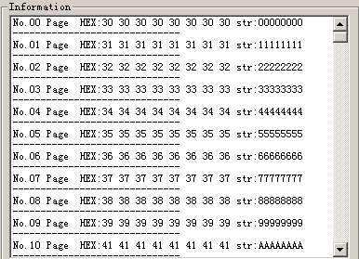
  - Write character
The start data page address for writing is 0-14.
The page lengh for writing only can write a page onet time, other value invalid.
The operating step for test reader’s『write』function is as below:
  - Select a tag which are ready to be write from the『written data』frame. At most 8 bytes can write on one page.
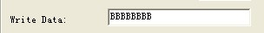
  - Fill the address for writing data:
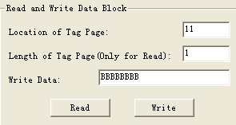
  - Press『write data』button, the program will start to write repeatly and automatically, until popup this button.
  - The operating result showed in the『information』frame.
If showed『write date failed』, represents this writing operation failed, the reason may be too long distance, this bank has been reading protected or has been destroyed.
  - Set page protection
The operating step is as below:
Select a tag which are ready to be protected from the 『choose a tag』frame.
  - Fiil the start page of the selected tag in 『data protection』, such as 12. The address range of the tag is 0-14. Fill in the pages should be protected.
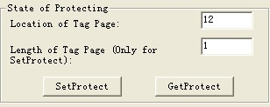
  - Press『set protection』button, popup『protect the twelve page』dialogue frame:
  - Press『yes』, the program will continue to select address to protect. Protecting success popup in the 『information』frame.
  - Detect the page protection
The operation steps are as below:
  - Select a tag which are ready to be detect from『select a tag』frame
  - Fiil the start page of the selected tag in 『data protection』, such as 12. The address range of the tag is 0-14. Fill in the pages should be protected, the page should be 1, and others are invalid.
  - Press『detect protection situation』butoon, pop up the below frame, represents this page has been protected.

