RFID Integrated Reader
Product information guidance

- We have the revise authority about product hardware, software and the manual. The manual modified without notice
- The model and power of equipment is subject to the origin country, Please confirm the voltage and read relevant safety attentions, especially in outdoor Installation
- Content
1 Content 2
2 Product summary 3
2.1 Shape and interface 3
2.2 Performance index 4
2.3 Function 5
3 Euipment installation 6
3.1 Connection 6
3.2 Connect reader and controller 6
3.3 Connect the power supply 7
3.4 Euipment adjustment 7
3.5 Stick the tag 8
4 Common malfunction 9

- Product summary

is the lastes integrated reader which developed by our company.it can read the tag or card which according to the protocol of ISO 18000-6B, EPC CLASS 1 G2. It can be used in vehicle management, ETC, Personnel access control, electronic anti-counterfeiting, logstic monitor, production auto managemtn system and so on.
  - Shape and interface
The appearance of as the follow photo shows. With ABS case, it can be installed in indoor environment or outdoor environment where has good ventilation, dust-proof and rain-proof conditions.
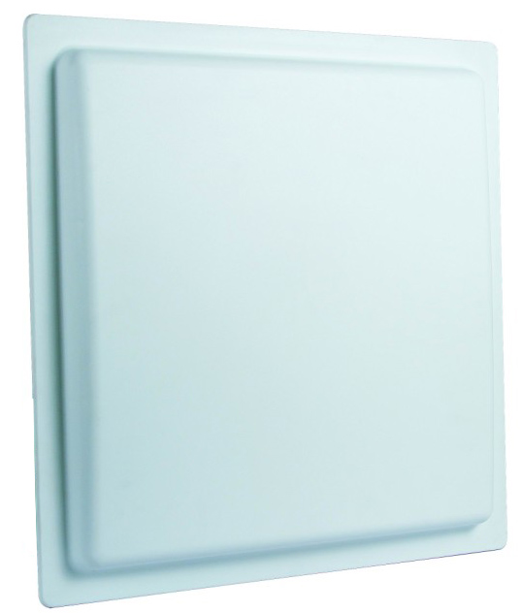
There is a feeder interface at the bottom of , the details of the cable as follow shows:
Red |  | Black | Blue | yellow | Grey | Light blue
+9/12V |  | Power  GND | Wiegand_Data1 | Wiegand_Data0 | Trigger input | Relay1
Purple |  | Orange | Brown | Dark green | White | Pink
485+ |  | 485- | Signal GND | 232Tx | 232Rx | Relay2
2-1-2
The features of the communication interface in the table 2-1-2:
- RS232 communication interface:
1 RS232 port(DB9 socket:RxD receive、TxD send、signal GND)－it can connect with PC
- Buzzer: built-in buzzer, it will alarm when the reader read the tags.
- Power interface:+9/12V DC socket(red and black)。
- I/O port
- 1 RS485 port(485+(purple)、485-(orange)differential siganl)－ used for long range signal transmission
- 1 Wiegand port: it usually used for tansmit ID number of the tag in access control system.
Wiegand port: WDATA1-0(yellow)、WDATA1-1(blue)
- Signal ground(Brown): it is for Wiegand port and RS232 port
- 1 trigger signal input port: FIN1(grey)，Low level trigger.
When the reader in trigger model, if connect this port to Low level, the reader will read tag automatically until it recover to high level.
  - Performance index
- Read/write tag: ISO18000-6B、EPC CLASS1 G2 tag
- Frequency:865～956MHz(Slight different in different counry and region)
- Work type: FHSS or fixed frequency emmision
- Output power:20～30dBm(Slight different in different counry and region)
- Read/writedistance: read distance>8m,
write distance>1m(depend on tags)
- Read speed: 32bits/6ms.
- Write distance:32bits/50ms
- Power supply: +9/12V DC.
- Power:averate power<5W。
- Work temperature:-10℃~+55℃。
  - Function
- Read/Write tag: ISO18000-6B、EPC Class1 Gen 2 tag
- It can read many different length EPC number(16、32、48、64、80 or 96bits) at the same time
- It can read selected EPC number of the tag
- It can read selected data of the tag in user memory
- It can read selected data of the tag in TID memory
- It can read the visit password and the kill password of the tag(both are 32 bits)
- It can write different length EPC number(16、32、48、64、80 or 96bits)
- It can write the data of the user memory
- It can change the visit password and kill password of the tag(both are 32 bits)
- There is write-protect function for EPC、TID and user memory
- There are read and write-protect function for password memory
- It can Kill the tag
- Euipment installation
  - Connection
In application system, the connection between reader, antenna, tag and the controller (PC) as follow graphic shows:
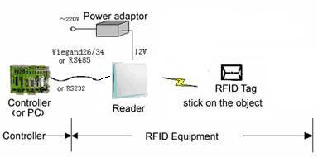
Graphic 3-1 Euipment connection
  - Connect reader and controller
reader can connect with controller (PC) through Wigand, RS485 or RS232 port, then receive and send the data.
  - Wiegand port
With wiegand communication, you need to connect 3 lead pin of Data0 (WDATA1-1 and WDATA2-1), GND with 3 correspondence lead pin in controller. The wiegand port can only send the data.
  - RS485 port
With RS485 communication, you need to connect 2 lead pin of RS485+/RS485- in reader with 2 corresponding lead pin in controller.
  - RS232 port
With the assorted cable, you can connect RS232 port directly with PC, the length of the cable should less than 10m in construction work. The connection as follow graphic shows:
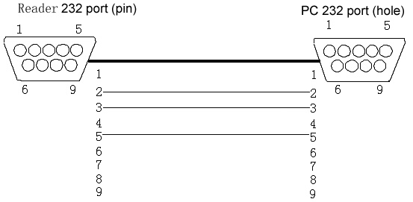Graphic 3-2-2 Reader RS232 connect with PC
  - Connect the power supply
Reader A/N use +9/12V/3A DC to porive the power.we will provide relevant power adaptor together with the reader. Connection as follow steps:
- Check and confirm the voltage and the frequency of the A.C. source,if they meet the requirement of AC 100-240V/50Hz.
- Connect the DC output connector plug with +9/12V DC input port in reader.
- Connect 220V AC input plug of the adaptor to AC circuit.
- The indicator light up, it shows power supply input normally.
  - Euipment adjustment
Key factor for adjustment: adjust the height, direction angle, angle of inclination of the antenna until the reader can read the tag in expected area. Steps as follows:
- Open the reader power supply, set as continuting work model, close the program and disconnection of the reader with PC.
- Disconnect the power supply and then connect, the reader will work under continuting work model.
- For different material of identified object, it needs to use different tags. So when adjusting,you need to put the tag near the identifided object and then move the tag.if the reader can get the information of the tag,the buit-in buzzer will alarm and the green LED will light.
- Adjust the height and angle of the antenna carefully and find an optimal read coverage.
Note: The reader only send the microwave power when read and write tags.it can meet the American FCC RF items requirement when there is 30cm distance between adjustment engineer and the antenna.
  - Stick the tag
In the application of RFID system, sticking the tag is the common work.the notice we need to do as follows:
- Use the glue we recommend.
- For the tag used in metal surface, use special glue.
- It needs to do the test to find a suitable place and ensure the ideal read/write effect.
Note: we provide 2 kinds of ISO18000-6B tags:
- Air medium.can use directly in hand; it can also use together with the Cassette we developed.it can insert the card directly in the cassette.
- Glass medium.it need to stick on the glass(with the Insoluble glue)
- Common malfunction
Table 4-1 common malfunction and solutions
Malfunction phenomenon | Possible reason | Solutions
Can not detect the tag | Antenna not connect well | Check the antenna connection
Can not detect the tag | Exceed the read coverage | Move the tag to the antenna
Can not detect the tag | Antenna damaged | Change antenna
Can not detect the tag | RF Power is too low | Restore the factory parameter
Can not detect the tag | Tag damaged | Change tags
Can not detect the tag | Reader damaged | Contact with the technician
Can not connect the reader | No power supply | Check the connector and the adaptor of the power supply
Can not connect the reader | Com port occupied or damaged | Check if the com port is occupied through the software and test if the port can communicate
Can not connect the reader | Baud rate is not unanimous | Set the unanimous Baud rate through the software
Can not connect the reader | Reader damaged | Contact with the technician
Short read distance | Antenna not connect well | Check the antenna connection
Short read distance | RF Power is too low | Restore the factory parameter
Short read distance | The polarization of the tag is not unanimous with the antenna | Rotation 90°of the tag
Short read distance | Reader damaged | Contact with the technician
Short read distance | Tag damaged | Change tags

